CIRU Social, Environmental and Economic Sustainability of Rugby in the COOK ISLANDS

Sustainability Principle
CIRU acknowledges as has been expressed by World Rugby, that “Issues of economic, social and environmental sustainability have increasingly come into focus as the world faces financial risks, societal demands and ecological threats. In a sporting context, rugby is also impacted and must always identify challenges and opportunities to ensure the continued practice and enjoyment of the game in a sustainable manner”.
“Sport is also an important enabler of sustainable development. We recognize the growing contribution of sport to the realization of development and peace in its promotion of tolerance and respect and the contributions it makes to the empowerment of women and of young people, individuals and communities as well as to health, education and social inclusion objectives.”"
UN 2030 Agenda for Sustainable Development

The Cook Islands Rugby Union recognises its role and the need to collaborate with stakeholders to identify and manage available and potential resources in a sustainable way. This will ensure that decisions taken today have a positive impact not just on the game for existing players, fans and other stakeholders, but for the economy, environment and society for generations to come.
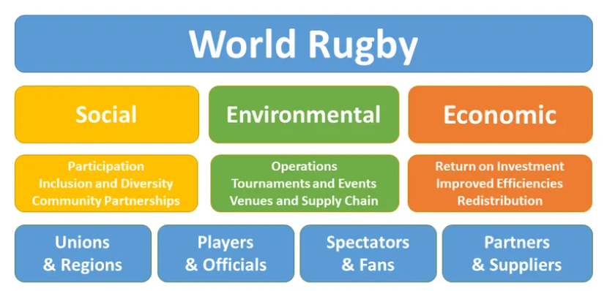
Social Sustainability Safeguards
The Cook Island Rugby Union already has several policies to sustain its commitment to inclusion and diversity. These policies include:
Declaration on Human Rights and Rugby in the Cook Islands
Rights of the Child
Rights of Persons with Disabilities
Elimination of Discrimination Against Women
CIRU Framework – Safe Sporting Environment
Environmentally Sustainable Development
Policies have also been established to ensure a safe environment for the development of skills and capacity of both players and officials.
2020 CIRU Player Training & Education Plan
2020 Medical Strategy Pathway
CIRU Transition and Retention Report 2020
2020 CIRU Competition Pathway – Training and Education Plan
2020 CIRU Match Official Strategy
2020 CIRU Coach and Strengthening and Trainer Conditioning Pathways
Economic sustainability
The Cook Islands Rugby Union Executive Committee has incorporated strategies into its annual plans to ensure the development of positive relationships with government, regional and local corporate sponsors, partners and suppliers, to ensure that the Cook Islands can continue to support our economic capacity for sustainability of our Game and our events. Economic capacity is important to enable us to both continue to hold regular and a more flexible range of rugby events in the Cook Islands, as well as to support the opportunities for our Cook Islands players to represent their country in international events. The CIRU strategic plan focuses on securing the commitment of our rugby communities by ensuring that the Game is played in such a way that it encourages support (financial, in-kind and by their continued attendance at competition games) from the clubs and the communities that their players represent with their efforts both on and off the field.

